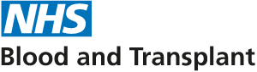

COVID 19 Blood Plasma Research

Recovered COVID 19 patient blood plasma required in a national research effort against coronavirus
NHS Blood and Transplant needs people who have recovered from COVID-19 to donate blood plasma (convalescent plasma).
Although there is some evidence globally that patients with COVID-19 may benefit from receiving donated plasma, this research will inform the blood and transplant team on how safe and effective blood plasma is for treating patients with Coronavirus.
Plasma that is donated and determined to have sufficient levels of antibodies will be used for patients being treated with COVID-19. These antibodies may help patients to recover from Coronavirus by supporting their immune response.
NHS Blood and Transplant are looking to recruit anyone who has recovered from a confirmed case of Coronavirus at 23 of their main blood centres.
If you know someone, or you yourself have recovered from COVID-19 then you may be eligible to donate. Please contact the NHS Blood and Transplant via the link below to let them know you are interested in donating.
Further information can be found here:
Plasma programme - COVID-19 research and trials

