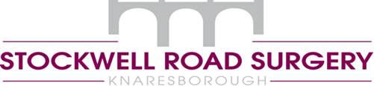
July 2020

Re: Guidance note for patients requesting exemption letters for facemasks
We are aware that some patients might be understandably anxious about the Government’s recent announcements around the use of face masks in various public settings.

GPs are unfortunately not in a position to provide individual risk assessments or letters for patients who feel that they should be exempt from wearing a face mask.

YOR Local Medical Committee has therefore prepared this guidance note as the statutory body that advises and supports all GPs and practice teams across North Yorkshire.

The government guidance on exemptions suggests there is no requirement for evidence for exemption therefore it is sufficient for an individual to self-declare this.

The responsibility for issuing exemptions does not lie with your GP. Practices are under no obligation to provide letters of support for anyone who does not fall under the list of exemptions but considers them to have another reason to be exempted.

Government advice on the use of face coverings can be found here:
https://www.gov.uk/government/publications/face-coverings-when-to-wear-one-and-how-to-make-your-own
Some people don’t have to wear a face covering including for health, age or equality reasons.
We hope that this guidance provides some reassurance for you on this issue.

Yours sincerely

Dr Dixon, Sanderson, Travis & McCready

